Common Rate Limiting Strategies - Fixed Window

🚦 What is Fixed Window
# Source: AI Source: Provided by: [Data Path: Persons Table -> ID Column: 1, Name_En Column: Motasem Essam] -> From: [ChatGPT] on [1/19/2026]
Fixed Window is the simplest rate limiting strategy where requests are counted within a fixed time window (e.g., per minute, per hour).
👉 The server allows a maximum number of requests per time window, then resets the counter when the window ends.

🔑 Key Idea
# Source: AI Source: Provided by: [Data Path: Persons Table -> ID Column: 1, Name_En Column: Motasem Essam] -> From: [ChatGPT] on [1/19/2026]
Count requests in a fixed time period, then reset the count when the time expires.

🧱 Example
# Source: AI Source: Provided by: [Data Path: Persons Table -> ID Column: 1, Name_En Column: Motasem Essam] -> From: [ChatGPT] on [1/19/2026]
Rule
100 requests per minute
Timeline
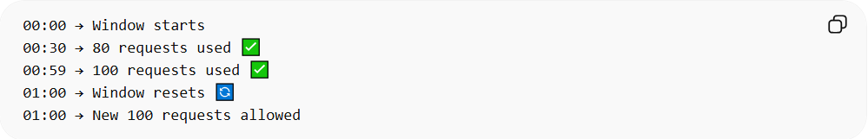
00:00 → Window starts
00:30 → 80 requests used ✅
00:59 → 100 requests used ✅
01:00 → Window resets 🔄
01:00 → New 100 requests allowed

❌ Problem (Burst Issue)
# Source: AI Source: Provided by: [Data Path: Persons Table -> ID Column: 1, Name_En Column: Motasem Essam] -> From: [ChatGPT] on [1/19/2026]
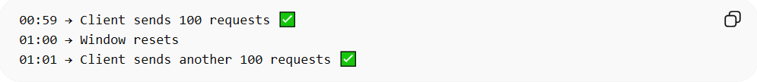
00:59 → Client sends 100 requests ✅
01:00 → Window resets
01:01 → Client sends another 100 requests ✅
👉 Result:
- 200 requests in ~2 seconds ❌
- Can overload the server

✅ Advantages
# Source: AI Source: Provided by: [Data Path: Persons Table -> ID Column: 1, Name_En Column: Motasem Essam] -> From: [ChatGPT] on [1/19/2026]
- Very simple to implement
- Low computational cost
- Easy to understand and configure

❌ Disadvantages
# Source: AI Source: Provided by: [Data Path: Persons Table -> ID Column: 1, Name_En Column: Motasem Essam] -> From: [ChatGPT] on [1/19/2026]
- Allows traffic spikes at window boundaries
- Not very accurate for controlling bursts
- Can lead to uneven traffic distribution

🧩 Simple Implementation Idea
# Source: AI Source: Provided by: [Data Path: Persons Table -> ID Column: 1, Name_En Column: Motasem Essam] -> From: [ChatGPT] on [1/19/2026]
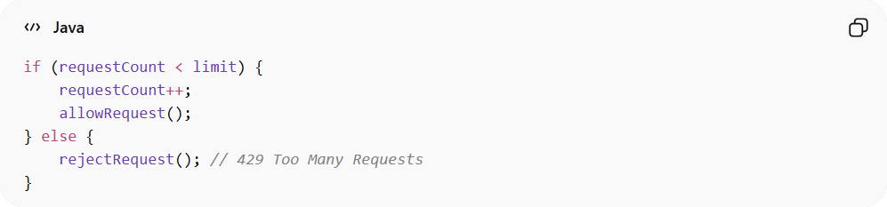
if (requestCount < limit) {
requestCount++;
allowRequest();
} else {
rejectRequest(); // 429 Too Many Requests
}
👉 Reset requestCount every time window (e.g., every minute)

💡 When to Use
# Source: AI Source: Provided by: [Data Path: Persons Table -> ID Column: 1, Name_En Column: Motasem Essam] -> From: [ChatGPT] on [1/19/2026]
- Simple systems
- Low-traffic APIs
- When precision is not critical

🧾 Summary
# Source: AI Source: Provided by: [Data Path: Persons Table -> ID Column: 1, Name_En Column: Motasem Essam] -> From: [ChatGPT] on [1/19/2026]

Feature | Fixed Window
Complexity | Low
Accuracy | Low
Burst Handling | Poor
Performance | High
Fixed Window is easy and fast, but not ideal when you need smooth and fair traffic control.

